Application to Join a Program
Youth Flourish Outdoors
PART 2: Family PARENT/GUARDIAN/WORKER TO COMPLETE
Young Person’s name:

Please list all members of the young person’s family/foster family/residence:

Name | Age | Relationship to young person

Are there other people who are important yet absent from the young persons living situation? If so please list and describe:
Name | Age | Relationship to young person

What do YOU see as the young person’s strengths?

What are the challenges relating to the young person at home?

If there are challenges/difficulties at home, what has helped in trying to resolve or manage these?

What are you hoping your young person may get out of this program?

Is there any other relevant family information?

To Feel Safe about this Program I also Need to be Sure That:

Parent/Guardian’s Statement

1.

2.

3.

Parent/Guardian’s Signature: ___________________________________

Name: ___________________________________

Thank you
Strengths and Difficulties Questionnaire (Parent or Teacher version)

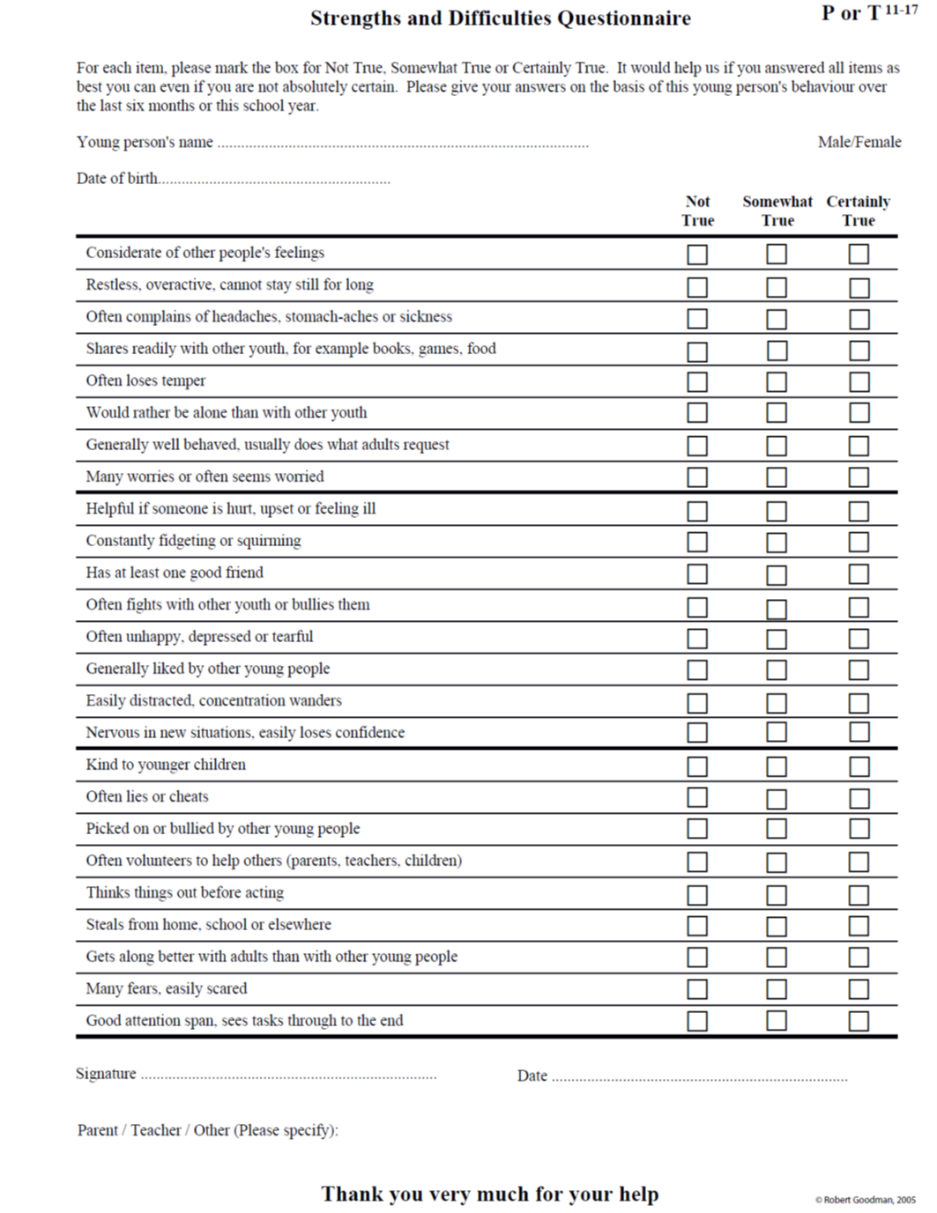
PARENT/GUARDIAN CONSENTS

Ensuring that your Young Person is Safe, Happy and Grows through the Flourish Program

I ___________________________________ being parent/guardian of the above-mentioned participant declare that I understand that ____________________________ (my child’s name), will be participating in a program conducted by Youth Flourish Outdoors Ltd (Flourish) and I consent to the following:
Activities Activities may involve running, jumping, water and use of specially designed adventure equipment thus exposing my son/daughter to situations and physical activity not encountered in a classroom. Flourish sometimes engages venues and eternal staff in which case our staff supervise but do not conduct the activity.
Risks I acknowledge that while Flourish and its staff and associated instructors will make every reasonable effort to minimise exposure to known risks, all hazards and dangers associated with these activities cannot be foreseen or may be beyond the control of Flourish, its staff or associated instructors.

Medical I authorise that Flourish staff may, in the event of any injury or illness, and where it is not possible or reasonable to obtain my consent at the time, administer a normal dose of over the counter medication such as antihistamine or paracetemol, to engage any medical practitioner or hospital facilities or accommodation. In this event I agree to pay all such emergency evacuation, ambulance, doctor, nurse, and/or hospital expense.

Medical Treatment: I authorise any employee of Flourish, who is with my child/ward, to consent, where it is impractical to communicate with me, to my child receiving such medical or surgical treatment as may be deemed necessary.

Counselling: I authorise Flourish therapists to counsel with a trauma focused approach and other Flourish staff to counsel in a trauma informed approach. I understand that both categories of counselling are as described in the Australian guidelines for the Treatment of Complex Trauma and trauma Informed care and Service provision (2012).

Photo’s and Film I give Flourish permission to use photographs and film footage taken during the course of the program for display or promotional purposes. I understand that my child will not be identified by name, address or any personal details.
Yes No

Vehicles I give permission for my child to be transferred by Flourish vehicles during program hours.

Information Flourish may share information, in the best interests of this young person, with other organisations. This includes for research, providing information is de-identified.

Safe Touch To keep this young person safe and happy Flourish staff (and staff trained in safe touch by Flourish) may touch for physical safety, and hug for emotional safety. The training required for this is understood to ensure that inappropriate touching is forbidden.

Group Rules Rules that the young people and staff create for ensuring emotional and physical safety are important and this young person will adhere to these rules.

Parent/Guardian sign:

date:
Medical Information

Name of Young Person | _____________________________ | Date of Birth:_________  Gender:_____________
Main Caregiver Name  Relationship | _____________________________  _____________________________ | Phone BH:________________
Address | _____________________________ | Mobile: _____________
 | _____________________________ | Postcode:____________
Medicare Number:  Health Care Card | _____________________________  _____________________________
Private Health Insurance | _____________________________ | Fund: ______________
Second Emergency Contact Name  Relationship | _____________________________  _____________________________ | Phone (mb):__________
Address | _____________________________
 | _____________________________ | Postcode: ____________
Doctor:  Name/Practice: | _____________________________ | Phone: ______________
Address | _____________________________ | (mobile):___________
 | _____________________________
Does this young person take any medication? Yes No
If yes, please give details: ______________________________________________________
________________________________________________________________________
Date of last Tetanus injection: ___________________
Does this young person suffer from any medical or psychological conditions/issues? Yes No
If yes, please give details:
________________________________________________________________________
Does this young person have any known allergies? Yes No
If yes, please give details: (include food, insect bites or medication)
________________________________________________________________________
Does this young person have any special dietary requirements? Yes No
If yes, please give details: ________________________________________________________________________
Can this young person swim 30 metres? Yes No
Are there any special requirements for medical or religious reasons? Yes No
If so, what are they? __________________________________________________________
________________________________________________________________________
Does this Young Person have permission to smoke? Yes No

I have submitted all relevant, up to date medical information on my child and I understand that my child is responsible for bringing all required prescription medications with them on the Flourish program/s.
Yes No

Parent/Guardian (signature).............................................. Date...........................

